**Subquery**

**Introduction**

A subquery is a SELECT statement that is nested within another statement. The subquery is also called the **inner query** or **nested query**. A subquery may be used in:

* SELECT clause
* FROM clause
* WHERE clause

A subquery is usually embedded inside the WHERE clause. You may use comparison operators such as >, <, =, IN, NOT IN with WHERE clause.

Here is the syntax:

SELECT column_name

FROM table_1, table_2

WHERE column_name OPERATOR (

SELECT column_name

FROM table_1, table_2);

Herein the query

SELECT column_name

FROM table_1, table_2

WHERE column_name OPERATOR

is called the outer query.  
  
The query

(SELECT column_name

FROM table_1, table_2)

is called inner query (nested or subquery query). The inner query is executed first before the outer query. The results of the inner query are passed to the outer query.  
  
There are some rules when using subquery:

* A subquery must be enclosed in parentheses.
* An ORDER BY clause is not allowed to use in a subquery.
* The BETWEEN operator can't be used with a subquery. But you can use BETWEEN within the subquery.

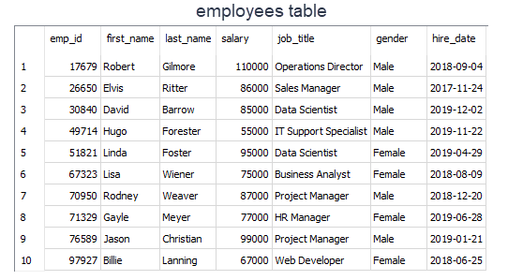

Let's do an example. We'll find the employees who get paid more than Rodney Weaver. Our query should return first name, last name, and salary info of the employees.  
✍ Give it a try before seeing the solution.  
  
Click for the solution

query:

SELECT first_name, last_name, salary

FROM employees

WHERE salary >

(SELECT salary

FROM employees

WHERE first_name = "Rodney");

output:

first_name last_name salary

---------- ---------- ----------

Robert Gilmore 110000

Linda Foster 95000

Jason Christian 99000

* The inner query returns 87000 which is the salary of Rodney and passes this value to the outer query, in particular to the WHERE clause. (WHERE salary > 87000)
* In the outer query, WHERE clause filters the employees whose salary is more than 87000 and returns the first name, last name, and salary info of those.

There are three main types of subqueries:

* Single-row subqueries
* Multiple-row subqueries
* Correlated subqueries*

Now, let's find out them.  
* : This type of subquery will not be covered in the course.

Q: What is a Subquery?  
A: A subquery is a query within another query, also known as nested query or inner query . It is used to restrict or enhance the data to be queried by the main query, thus restricting or enhancing the output of the main query respectively.

### Single-Row Subqueries

Single-row subqueries return one row with only one column and are used with single-row operators such as **=**, **>**, **>=**, **<=**, **<>**, **!=** .

Scalar subquery which returns a single row with one column is an example of single-row subqueries. In the [previous lesson](https://lms.clarusway.com/mod/lesson/view.php?id=3979&pageid=5069), we have shown you a single-row subquery example by finding Rodney's salary that returns a single row with one column (87000).

##### 

We can also use aggregated functions since it returns a single row with a single column. Now let' s find out the employees who get paid more than the average salary. Our query should return first name, last name, and salary info of the employees.

##### **query:**

SELECT first_name, last_name, salary

FROM employees

WHERE salary >

(SELECT AVG(salary)

FROM employees);

##### **output:**

first_name last_name salary

---------- ---------- ----------

Robert Gilmore 110000

Elvis Ritter 86000

David Barrow 85000

Linda Foster 95000

Rodney Weaver 87000

Jason Christian 99000

##### **Let's analyze the query above:**

##### **We've used > operator with WHERE clause.**

##### **The inner query returns the average salary which is 83600 and passes this single value to the outer query.**

##### **Outer query filters those employees and returns those whose salary is more than 83600.**

As you see that combining aggregate functions with subqueries, we have more power to answer our analytical questions.

### Multiple-Row Subqueries

Multiple-row subqueries return sets of rows and are used with multiple-row operators such as IN, NOT IN, ANY, ALL.  Now, let's see it in an example.

As you know that we have added a new table to the company database consisting of one table. Our new table is the departments table. It has three columns and nine rows. Every row represents an employee's department info. Here are our database tables.

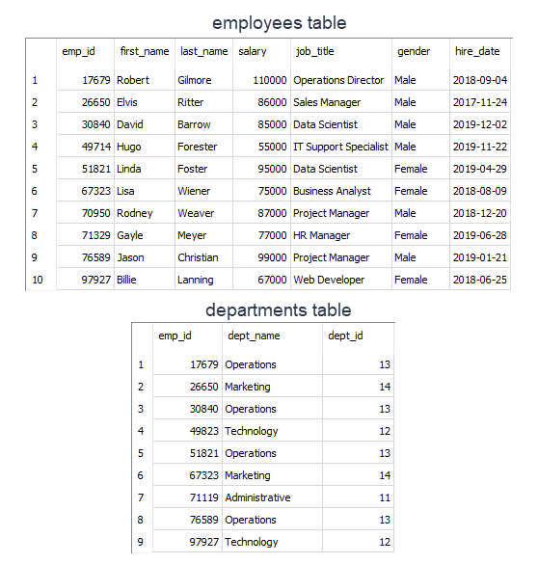

Now with that said, find the employees (first name, last name from employees table) who work under the Operations department (departments table). Our query should return first name and last name info.

query:

SELECT first_name, last_name

FROM employees

WHERE emp_id IN

(SELECT emp_id

FROM departments

WHERE dept_name = 'Operations');

output:

first_name last_name

---------- ----------

Robert Gilmore

David Barrow

Linda Foster

Jason Christian

Let's analyze the query above:

* We've used IN operator with WHERE clause.
* The inner query returns the employees ids who work under the Operations department and passes those to the outer query.
* Outer query filters those employees ids and returns their first_name and last_name as a result set.